DCEE-CausalVerse: Event-Grounded Causal Planning for Ending-Controllable Visual Storytelling
Dohyoung Kim, Kyungmin Na, Youngho Lee
kdhms@ncsoft.com, {nkm1112, lyh}@gachon.ac.kr
AI Data Lab, NC AI
Department of IT Convergence Engineering, Gachon University, Seongnam-si 13120, South Korea
Department of Computer Engineering, Gachon University, Seongnam-si 13120, South Korea
Abstract
Recent text-to-image diffusion models can synthesize high-quality images from natural language prompts, yet visual storytelling remains challenging because a coherent visual story must preserve character identity, world state, event continuity, and emotional progression across multiple frames. Existing story visualization methods mainly focus on rendering a given caption sequence into consistent images or maintaining recurring subjects across frames. However, they often treat frames as locally grounded caption-image pairs and do not explicitly model why a final emotional state emerges from preceding visual events. In this paper, we study ending-controllable causal visual storytelling, where the generated image sequence must not only express a target ending emotion but also visually justify the causal path leading to that emotion. We propose DCEE-CausalVerse, a framework that decomposes a target ending emotion into Desire, Conflict, Event Chain, and Ending Emotion (DCEE). Rather than generating a single Desire-Conflict route, our DCEE-Tree planner explores multiple Desire-Conflict trajectories and selects the event chain that best explains the target ending emotion. The selected plan is then canonicalized into drawable events and visual evidence, maintained through causal sink memory and a DCEE anchor bank, and translated into diffusion controls by a decoder-encoder-decoder DCEE Butterfly Visual Controller. For each frame, the controller expands the DCEE plan into visual hypotheses, fuses them with causal memory and anchor information, and decodes the fused representation into factorized Character, World, Emotion, Event, and Evidence branches. These branches are injected into the diffusion model as cross-attention control tokens to guide frame generation. Multiple candidates are generated autoregressively and reranked based on event grounding, evidence visibility, emotion visibility, event-emotion causal consistency, identity consistency, and world consistency. Experiments show that DCEE-CausalVerse produces more causally coherent visual stories with clearer emotional progression and stronger cross-frame consistency than caption-only and subject-consistency baselines. Our key insight is that emotional controllability in visual storytelling requires not only rendering the target emotion, but also constructing visible causal evidence that makes the emotion narratively justified.

1. Introduction
Text-to-image diffusion models have made rapid progress in producing visually compelling images from natural language prompts. However, visual storytelling is more demanding than single-image generation because each frame must simultaneously satisfy local text-image alignment and global story consistency. The protagonist should remain recognizable, important objects should persist or reappear when causally needed, the world should evolve coherently, and the emotional tone should change in a narrative rather than arbitrary manner.
Most existing visual storytelling systems treat the input as a sequence of captions and attempt to visualize each caption while maintaining history consistency. This is useful when the story is already fixed, but it does not directly answer a more controllable question: given an initial premise and a target ending emotion, what sequence of events should happen so that the final emotion becomes believable, and how should those events be visually grounded? A direct prompt such as 'generate a sad ending' may produce a gloomy portrait, but it often fails to show the event and visual evidence that explain the sadness.
We argue that ending-controllable visual storytelling requires causal narrative planning. The final emotion should not be a surface-level style label; it should be the result of a protagonist's desire, a central conflict, and a chain of visually drawable events. Moreover, every emotional transition should have visible evidence. For example, a sad frame should not simply contain a sad face; it should show the lost object, empty hands, rainy riverbank, or broken clue that makes the sadness understandable.
To address this problem, we propose DCEE-CausalVerse. The core representation is DCEE: Desire -> Conflict -> Event Chain -> Ending Emotion. We further extend this representation with DCEE-Tree Planning, which samples multiple Desire-Conflict trajectories before selecting the event chain that most strongly supports the target ending emotion. The selected plan is canonicalized into explicit entities, drawable events, visual evidence, and world-state cues. During generation, causal sink memory selects not just visually similar history but emotionally causal memory, while the DCEE anchor bank maintains recurring characters, evidence objects, and world anchors.
A key component of our method is the DCEE Butterfly Visual Controller. Unlike a simple prompt generator, this module follows a decoder-encoder-decoder structure. It first expands a DCEE frame into diverse visual hypotheses, then encodes them with causal memory and anchor constraints, and finally decodes the fused state into factorized Character, World, Emotion, Event, and Evidence controls. These controls are converted into cross-attention tokens for SDXL, enabling structured conditioning while avoiding overly long prompts and control entanglement.
Contributions.
We formulate ending-controllable causal visual storytelling, where a generated visual story must justify a target ending emotion through a causally ordered event chain.
We introduce DCEE-Tree Planning, which explores multiple Desire-Conflict routes and selects the event chain with the strongest causal support for the target ending emotion.
We propose causal sink memory and a DCEE anchor bank to preserve identity, world state, conflict state, event evidence, and emotion-cause information across frames.
We design a decoder-encoder-decoder DCEE Butterfly Visual Controller that maps symbolic DCEE frames into factorized Character, World, Emotion, Event, and Evidence controls.
We introduce event-evidence-aware reranking and retry generation using event grounding, evidence visibility, emotion visibility, and event-emotion causal consistency.
2. Related Work
2.1. Diffusion-based Story Visualization
Story visualization aims to generate a sequence of images that corresponds to a multi-sentence narrative while preserving semantic coherence across frames. Early work such as StoryGAN [14] formulated story visualization as generating one image per sentence and introduced a sequential conditional GAN with story-level and image-level discriminators to improve global consistency. Later, StoryDALL-E [15] adapted pretrained text-to-image transformers for story continuation, showing that large pretrained image generators can be retrofitted for sequential visual narrative tasks. With the success of diffusion models, AR-LDM [2] extended latent diffusion models to auto-regressive story synthesis by conditioning each frame on previous captions and generated images. Make-A-Story [3] further introduced a visual memory mechanism and sentence-conditioned attention to maintain actor and background consistency across frames.
Recent diffusion-based methods improve story coherence by modeling history more selectively. ACM-VSG [4] argues that not all previous frames contribute equally to the current frame and introduces adaptive context modeling for visual story generation. Intelligent Grimm / StoryGen [5] studies open-ended visual storytelling and constructs StorySalon, a large-scale dataset of paired image-text sequences, while conditioning the current generation on previous image-caption pairs. Causal-Story [6] incorporates a local causal attention mechanism to weight previous captions and frames according to their causal relationship with the current caption. ViSTA [1] proposes a multi-modal history fusion module and a lightweight history adapter, together with salient history selection, to condition text-to-image diffusion models on relevant history features.
These methods provide important mechanisms for history-aware visual generation. However, they mainly assume that the story or caption sequence is already given and focus on rendering it coherently. In contrast, our work addresses ending-controllable causal visual storytelling: given an initial premise and a target ending emotion, the system must plan a plausible event chain and generate frames that visually justify why the target emotion emerges. Therefore, our DCEE-CausalVerse does not only ask whether a frame matches its local caption, but also whether the frame shows the event and evidence that causally support the protagonist’s emotional trajectory.
2.2. Subject-Consistent Image Sequence Generation
Another line of work focuses on preserving recurring subjects across multiple generated images. ConsiStory [9] introduces a training-free approach for consistent subject generation by sharing internal activations of a pretrained text-to-image model through subject-driven attention and correspondence-based feature injection. StoryDiffusion [8] proposes Consistent Self-Attention for long-range image and video generation, improving character and style consistency across generated sequences. One-Prompt-One-Story [19] concatenates all frame prompts into a single extended prompt and refines generation with Singular-Value Reweighting and Identity-Preserving Cross-Attention. DreamStory [10] uses LLM-generated subject and scene descriptions together with multi-subject consistent diffusion to preserve multiple subjects in open-domain story visualization.
Subject-consistent generation is complementary to visual storytelling because a stable protagonist identity is necessary for coherent stories. However, identity consistency alone is insufficient for ending-controllable storytelling. A visually consistent character may still fail to perform the planned event, interact with the required object, or express an emotion for an understandable reason. Our method therefore separates Character control from World, Emotion, Event, and Evidence controls. This factorization allows the protagonist identity to remain stable while the event, body pose, facial expression, world state, and evidence objects change according to the current DCEE frame.
2.3. LLM-guided Story Visualization and Multi-modal Story Generation
Large language models have increasingly been used as story directors, prompt generators, and reference resolvers for visual storytelling. StoryGPT-V [7] leverages LLM reasoning to resolve ambiguous references in story captions and aligns the LLM output with a character-aware latent diffusion model. DreamStory [10] uses an LLM as a story director to generate subject and scene prompts for multi-subject consistent visualization. SEED-Story [11] extends this direction to multimodal long story generation, using a multimodal large language model to produce interleaved narrative texts and images over long sequences.
These works demonstrate that language models can help organize story context and improve character grounding. Nevertheless, LLM-guided prompting can still produce abstract events, hallucinated entities, or emotionally plausible but visually unsupported frames. Our framework uses the LLM not merely as a prompt writer, but as a structured causal planner. The DCEE-Tree planner decomposes the target ending emotion into Desire, Conflict, Event Chain, and Ending Emotion, and then canonicalizes the selected route into drawable events, visible evidence, and world-state cues. This design constrains the LLM output so that each generated frame has explicit visual obligations: what happens, what object or clue proves that it happened, and how that evidence explains the protagonist’s emotion.
2.4. Narrative Planning and Controllable Story Generation
Controllable story generation has long recognized that coherent stories require planning beyond next-sentence generation. Hierarchical neural story generation first separates premise generation from full story generation [20]. Plan-and-Write [16] proposes a hierarchical framework that first plans a storyline and then generates the story from that plan. PlotMachines [17] introduces outline-conditioned generation with dynamic plot state tracking, emphasizing that coherent narratives require models to track changing plot states. Reward-shaping approaches to controllable plot generation [18] further show that story generation can be formulated as guiding a sequence of events toward a desired goal state.
Our work is closely related to this planning perspective, but differs in two ways. First, the target control variable is not a final verb, topic, or outline; it is a target ending emotion that must be made believable through visible events. Second, the output is not only text. The event plan must be translated into an image sequence in which the viewer can infer the emotional cause from visual evidence. DCEE-Tree Planning therefore treats ending emotion control as a search over possible Desire-Conflict-Event routes, and selects the route that provides the strongest causal and visual support for the final emotion.
2.5. Event, Evidence, and Faithfulness Evaluation
Evaluating visual stories requires more than measuring image quality or identity consistency. A frame may look visually appealing while failing to depict the intended action, object, or emotional cause. TIFA [12] evaluates text-to-image faithfulness by generating question-answer pairs from the text and checking whether a VQA model can answer them from the generated image. ViSTA [1] also adopts TIFA-style evaluation to assess narrative text-image alignment in visual storytelling.
Our evaluation follows this faithfulness-oriented direction but adapts it to causal emotional storytelling. We evaluate whether the generated image shows the planned event, whether the evidence object or visual clue is visible, whether the protagonist’s emotion is readable, and whether the visible event plausibly explains that emotion. This motivates our event-evidence-aware reranking and retry mechanism, which selects among multiple generated candidates using event grounding, evidence visibility, emotion visibility, event-emotion causal consistency, identity consistency, and world consistency. In this way, DCEE-CausalVerse evaluates not only whether a frame is attractive or consistent, but whether it visually supports the causal story arc leading to the target ending emotion.
3. Method
Figure 1 and Table 1 summarize the overall DCEE-CausalVerse pipeline. Given an initial image or text prompt, a protagonist description, and a target ending emotion, the framework first constructs a Global Story Bible that stores persistent story-level constraints, including protagonist identity, world attributes, recurring objects, and affective goals. It then explores multiple Desire-Conflict-Event Chain-Ending Emotion (DCEE) trajectories, selects the most plausible causal route, and canonicalizes the selected plan into drawable events and visual evidence. Next, the framework retrieves causal memory and anchor information, which are fused through the DCEE Butterfly Visual Controller to produce factorized Character, World, Emotion, Event, and Evidence controls. These controls are injected into the diffusion model as cross-attention tokens, enabling multi-candidate auto-regressive image generation. The generated candidates are finally reranked based on event grounding, evidence visibility, emotion visibility, causal consistency, identity consistency, and world consistency to obtain the final visual story sequence.

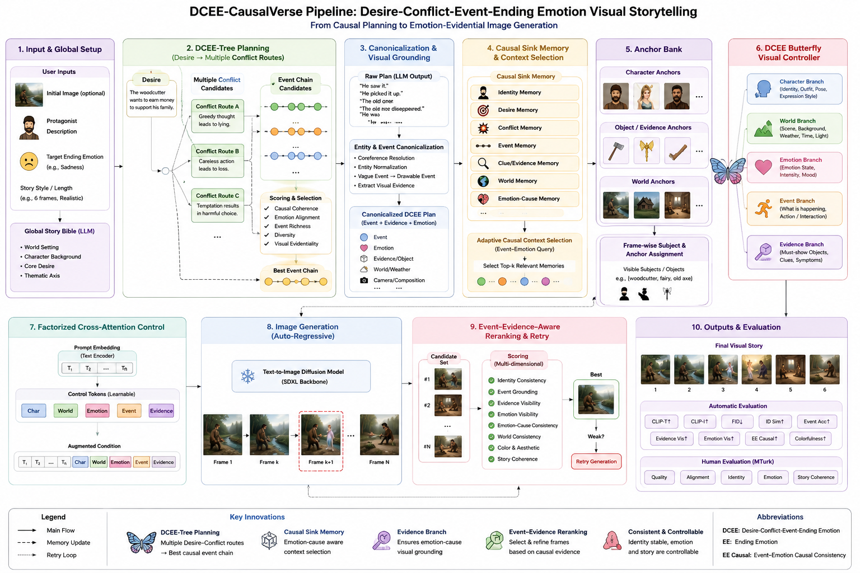
Figure 1. Overall pipeline of DCEE-CausalVerse.
Table 1. Step-by-step overview of the DCEE-CausalVerse pipeline.
Stage | Inputs | Core operation | Outputs / purpose
1. Input specification | Initial image or text prompt; protagonist description; target ending emotion. | Receive the story seed and the desired emotional ending condition. | Creates a structured input specification that defines the narrative starting point and affective objective.
2. Global Story Bible construction | Structured input specification. | Build persistent story-level constraints such as protagonist identity, world attributes, recurring objects, style constraints, and affective goals. | Establishes global character, world, and object constraints that should remain stable across the visual story.
3. DCEE-Tree planning | Global Story Bible and target ending emotion. | Explore multiple Desire-Conflict-Event Chain-Ending Emotion trajectories and generate candidate causal routes. | Produces alternative causal story hypotheses rather than committing to a single fixed route.
4. Route selection and canonicalization | Candidate DCEE plans. | Select the route with the strongest causal and emotional support, then canonicalize it into explicit events, entities, actions, and visual evidence. | Converts abstract causal plans into drawable frame-level story obligations.
5. Causal memory and anchor retrieval | Canonical event sequence and Global Story Bible. | Retrieve causally relevant prior states through causal sink memory and DCEE anchor bank, including identity, object, world, conflict, clue, and emotion-cause information. | Preserves temporal coherence, causal continuity, and recurring visual anchors.
6. DCEE Butterfly Visual Control | Canonical frame plan, retrieved memory, anchor information, and current context. | Process each frame through the decoder-encoder-decoder Butterfly controller: expand visual hypotheses, fuse them with causal constraints, and decode refined controls. | Bridges high-level narrative causality and low-level visual generation conditions.
7. Factor decomposition | Fused frame representation. | Decompose the fused state into Character, World, Emotion, Event, and Evidence branches. | Separates identity, setting, affect, action, and visible causal evidence so each factor can be controlled explicitly.
8. Cross-attention token injection | Five factor branches. | Encode factorized controls as cross-attention control tokens and append/inject them into the SDXL generation process. | Grounds diffusion generation in story-specific causal, emotional, and evidential information.
9. Multi-candidate auto-regressive generation | SDXL control tokens and previous-frame context. | Generate multiple candidate images for each frame auto-regressively. | Produces diverse but context-aware visual hypotheses for each story step.
10. Event-evidence-aware reranking and retry | Candidate frame images and canonical event/evidence targets. | Rerank candidates using event grounding, evidence visibility, emotion visibility, event-emotion causal consistency, identity consistency, world consistency, and image quality; retry generation if key scores are below thresholds. | Selects the frame that most faithfully reflects the intended story content and repairs weak generations.
11. Final visual story assembly | Best selected image from each frame. | Order the selected frames with their storyboard, control packets, and evaluation logs. | Outputs the final ending-controllable causal visual story sequence.
Table 1 functions as a roadmap for the Method section. Figure 1 provides the visual overview, while Table 1 specifies what each module receives, what computation it performs, and why the resulting output is necessary for ending-controllable causal visual storytelling. The table also clarifies that DCEE-CausalVerse is not a single prompt-generation step, but a staged pipeline that first plans a causally plausible emotional trajectory and then realizes it through factorized diffusion controls and event-evidence-aware candidate selection.
3.1. Problem Formulation
Let x denote the input premise, which may include an initial image, text description, protagonist information, and style constraint. Let e* denote the target ending emotion and K the number of frames. The goal is to generate an image sequence I_1:K and its storyboard S_1:K such that the final emotion aligns with e*, while each frame visually grounds the event and evidence that cause the protagonist's emotion. Unlike standard story visualization, the event chain is not assumed to be fully specified; it is planned as part of the generation process.
I_1:K = G(x, protagonist, e*)
DCEE = {Desire, Conflict, Event Chain, Ending Emotion}
3.2. Global Story Bible
The global story bible stores the information that should remain stable throughout the sequence. It contains the protagonist identity, world setting, key objects, visual style, central desire, possible conflicts, symbolic motifs, and target ending emotion. If an initial image is provided, an image-text understanding module extracts characters, scene, objects, mood, weather, time of day, and potential plot clues. The story bible becomes the global context used by all later modules.
3.3. DCEE-Tree Planning
A single Desire-Conflict route can produce a weak or generic event chain. We therefore propose DCEE-Tree Planning. The planner first fixes a protagonist desire, then samples multiple conflict routes conditioned on that desire. Each route is expanded into one or more event chain candidates. Every event must be causally related to the conflict, visually drawable, and capable of changing or intensifying the protagonist's emotion. The candidates are scored by causal coherence, alignment with the target ending emotion, event richness, visual evidentiality, and diversity. The highest scoring route is selected as the final DCEE plan.
Route_j = Desire -> Conflict_j -> EventChain_j -> EndingEmotion
Score(Route_j) = alpha Causal + beta Emotion + gamma VisualEvidence + delta Diversity + eta Coherence
This tree-based planning step is central to our novelty. It turns ending emotion control into a search problem over possible narrative causes. The final event chain is selected because it makes the target emotion believable, not because the emotion label is simply appended to a prompt.
3.4. Entity-Event Canonicalization
LLM-generated stories may contain ambiguous references and abstract events. The canonicalizer resolves pronouns and vague object references, normalizes recurring entities, and converts abstract events into drawable visual events. For example, 'he loses everything' is converted into visible evidence such as 'the woodcutter stands empty-handed beside a rainy riverbank while the broken axe handle floats away.' This step produces a canonicalized storyboard in which every event has explicit subjects, objects, actions, world context, and evidence objects.
3.5. Emotion-World Trajectory Planning
The emotion-world trajectory planner assigns each frame an emotion state, intensity, facial cue, body cue, lighting style, color palette, weather, camera shot, and composition. Emotions are not represented as labels alone. Sadness may require downcast eyes, slumped posture, rain, cool blue-gray colors, and negative space; joy may require bright eyes, open posture, warm light, and an open composition. The planner also records emotion_evidence and must_show fields that specify which objects or events must be visible to explain the emotion.
3.6. Causal Sink Memory and Adaptive Context Selection
During auto-regressive generation, the system stores selected information in causal sink memory. Unlike generic history, causal sink memory preserves only the information needed for future story coherence and emotional causality: identity memory, desire memory, conflict memory, event memory, clue/evidence memory, world memory, and emotion-cause memory. For each frame, adaptive context selection retrieves memory using an event-emotion query. The score combines event relevance, conflict relevance, emotion-cause relevance, clue relevance, and identity/world relevance.
M_k = Top-r Memories(q_k^{event-emotion})
score(m_i, q_k) = w1 event + w2 conflict + w3 emotion-cause + w4 clue + w5 identity/world
3.7. DCEE Anchor Bank
The DCEE anchor bank maintains three types of anchors. Character anchors store the protagonist and supporting characters' appearance, outfit, body shape, and signature items. Object/evidence anchors store causally important objects such as a broken axe handle, letter, ring, or weapon. World anchors store recurring backgrounds such as riverbank, forest, cottage, or city street. Each storyboard frame specifies visible subjects and evidence objects, which are mapped to corresponding anchors. This design extends subject consistency to evidence-object and world consistency.
3.8. DCEE Butterfly Visual Controller
The DCEE Butterfly Visual Controller is the bridge between symbolic narrative causality and diffusion-based image generation. The DCEE planner produces high-level causal structure, but the diffusion model requires visually grounded conditions such as identity, world state, emotional expression, event action, and visible evidence. Directly converting the entire storyboard into a single prompt is unreliable because prompts can exceed the text encoder limit, causal evidence can be truncated, and heterogeneous control factors can interfere. We therefore introduce a decoder-encoder-decoder controller that decomposes, fuses, and re-decodes DCEE information into factorized visual controls.
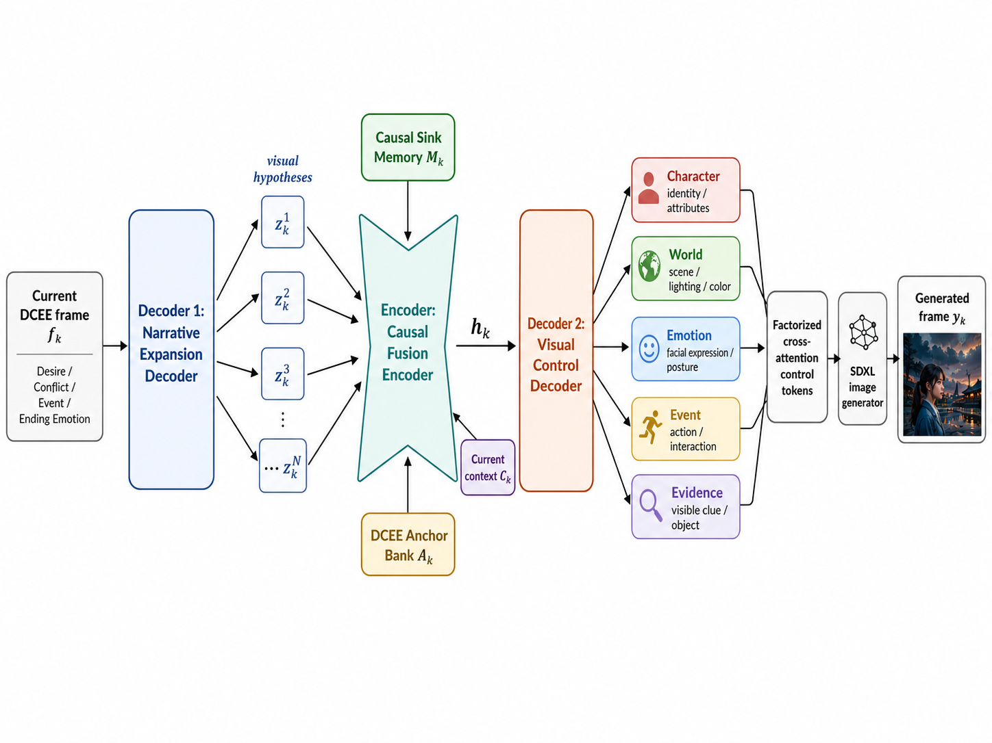
Figure 2. Decoder-encoder-decoder structure of the DCEE Butterfly Visual Controller.
Figure 2 illustrates the decoder-encoder-decoder structure of the DCEE Butterfly Visual Controller. The first decoder expands the current DCEE frame into multiple visual hypotheses; the central encoder fuses these hypotheses with causal sink memory, the DCEE anchor bank, and the current context; and the second decoder re-factorizes the fused state into Character, World, Emotion, Event, and Evidence controls. The resulting branches are converted into factorized cross-attention control tokens for SDXL, enabling the diffusion model to condition on identity, world state, emotional expression, action, and visible evidence without collapsing all constraints into a single long prompt.
3.8.1. Narrative Expansion Decoder
The first decoder expands the current DCEE frame into multiple visual hypotheses. Each hypothesis represents a different visual interpretation of the same event-emotion pair. For a sad ending, one hypothesis may be a close-up of the protagonist's regretful face, another may be a wide shot of the abandoned riverbank, and another may focus on a broken evidence object. This stage improves visual diversity and prevents the system from collapsing into generic emotional portraits.
Z_k = {z_k^1, z_k^2, ..., z_k^N}
3.8.2. Causal Fusion Encoder
The Causal Fusion Encoder compresses the expanded visual hypotheses into a compact representation that preserves the causal structure of the story. It receives visual hypotheses Z_k, selected causal memory M_k, anchor bank A_k, and current DCEE context C_k. It determines which visual elements are mandatory for narrative causality and which are optional variations. The encoder acts as the narrow waist of the butterfly: diverse visual hypotheses are forced through a causally grounded representation before being decoded into controls.
h_k = Encoder(Z_k, M_k, A_k, C_k)
3.8.3. Visual Control Decoder
The second decoder transforms the fused state h_k into five factorized control branches. The Character branch preserves identity, outfit, and recurring attributes. The World branch controls location, weather, lighting, atmosphere, and color. The Emotion branch controls facial expression, body posture, intensity, and affective palette. The Event branch specifies the current action or interaction. The Evidence branch specifies the visible objects, clues, spatial cues, and symbolic evidence that explain why the protagonist feels the current emotion. The Event and Evidence branches are intentionally separated: Event describes what happens, while Evidence describes how that event becomes visible in the image.
B_k = {b_char, b_world, b_emotion, b_event, b_evidence}
3.8.4. Difference from ViSTA-style History Adapters
ViSTA-style conditioning focuses on selecting salient text-image history and injecting history features to improve story consistency. Our controller has a different objective. It asks which desire, conflict, event, evidence, and emotional cause must be visible in the current frame, and then translates this causal structure into factorized diffusion controls. Therefore, the DCEE Butterfly Visual Controller is not merely a history adapter; it is a causal visual translation module that maps high-level narrative causality into low-level generation conditions.
3.9. Factorized Cross-Attention Control for SDXL
Each visual control branch is converted into branch-specific control tokens. These tokens are appended to the original SDXL prompt embedding and consumed by the U-Net cross-attention layers during generation. The factorized representation is:
H_aug = [H_prompt; H_char; H_world; H_emotion; H_event; H_evidence]
This design reduces the burden on a single long prompt, alleviates CLIP token truncation, and decouples identity, world, emotion, event, and evidence constraints. It also allows branch-specific weights to be increased during retry generation when a candidate image fails to show the target event, evidence, emotion, or colorfulness.
3.10. Auto-regressive Generation, Reranking, and Retry
Images are generated auto-regressively. After each frame, the selected image and its event, evidence, emotion, world state, and identity information are stored in memory. For each frame, the system generates multiple candidates and reranks them using image quality, identity consistency, event grounding, evidence visibility, emotion visibility, emotion-cause consistency, world consistency, story coherence, and colorfulness. If the best candidate falls below thresholds for event grounding, evidence visibility, emotion visibility, or colorfulness, the control packet is strengthened and the frame is regenerated.
S = lambda_id S_id + lambda_q S_quality + lambda_e S_event + lambda_v S_evidence + lambda_m S_emotion + lambda_c S_causal + lambda_w S_world + lambda_color S_color
3.11. Method Comparison
Table 2. Comparison between prior history-/subject-consistency approaches and DCEE-CausalVerse.
Aspect | Prior history- or subject-consistent methods | DCEE-CausalVerse | Reason for the design choice
Primary goal | Improve temporal coherence or preserve recurring subjects across frames. | Justify a target ending emotion through a causally grounded event chain and visible evidence. | Ending-controllable storytelling requires a believable cause for the final affective state, not only visual consistency.
Input assumption | The caption/story sequence is usually already given. | The event chain is planned from an initial premise, protagonist, and target ending emotion. | Our setting requires the system to decide what should happen before rendering the frames.
History use | Condition on recent or salient text-image history. | Retrieve causal sink memory according to event-emotion relevance. | The current frame uses the history that explains the current emotional state, rather than simply the most recent frame.
Control unit | Caption, subject prompt, or generic history feature. | Factorized Character, World, Emotion, Event, and Evidence controls. | Factorization separates identity preservation from action, setting, emotion, and causal evidence.
Event modeling | Events are often implicit in the caption or absorbed into prompt text. | Events are explicit DCEE units that are planned, canonicalized, grounded, and evaluated per frame. | Explicit event units make it possible to verify whether the generated image depicts the intended action.
Evidence modeling | Evidence objects or clues are usually not modeled separately. | Evidence is a separate branch specifying the visible cause, clue, or object that supports the protagonist emotion. | The target ending emotion is only narratively convincing when its cause is visible.
Generation controller | Prompt generator, history adapter, or identity-conditioning module. | Decoder-encoder-decoder Butterfly controller with causal fusion. | The controller translates symbolic narrative causality into low-level diffusion conditions.
Selection criterion | Image quality, text-image alignment, or subject consistency. | Event grounding, evidence visibility, emotion visibility, event-emotion causal consistency, identity consistency, and world consistency. | Candidate selection directly reflects the causal storytelling objective.
Table 2 shows that DCEE-CausalVerse differs from prior visual storytelling and subject-consistency methods in both objective and control granularity. Existing methods mainly focus on rendering a given sequence consistently, whereas our framework treats the ending emotion as a causal target that must be explained by visible events and evidence. This distinction motivates the separation of Event and Evidence branches and the use of causal memory rather than generic history reuse.
3.12. Algorithmic Summary
Algorithm 1. DCEE-CausalVerse inference procedure.
Input: x: input premise; a: protagonist description; e*: target ending emotion; K: number of frames; N: number of image candidates per frame
Output: final image sequence Y1:K, storyboard S1:K, selected DCEE plan P*, visual control packets, and evaluation logs
B ← BuildStoryBible(x, a, e*)
R ← GenerateDCEERoutes(B) // multiple Desire-Conflict-Event routes
for each route rj in R do
Ej ← ExpandEventChain(rj)
vj ← EvaluateRoute(rj, Ej, e*) using causal coherence, emotion alignment, visual evidentiality, diversity, and narrative coherence
end for
P* ← arg maxj vj
S1:K ← Canonicalize(P*) into drawable subjects, actions, evidence objects, world states, and emotion cues
M0, A0 ← Initialize causal sink memory and DCEE anchor bank
for k ← 1 to K do
qk ← event-emotion query from current DCEE frame fk and storyboard Sk
Mk ← RetrieveCausalMemory(qk, Mk−1) using event, conflict, clue, emotion-cause, identity, and world relevance
Zk ← Decoder1(fk) = {zk1, zk2, ..., zkN} // narrative expansion into visual hypotheses
hk ← CausalFusionEncoder(Zk, Mk, Ak, Ck)
Bk ← Decoder2(hk) = {bchar, bworld, bemotion, bevent, bevidence}
Haug ← [Hprompt; Hchar; Hworld; Hemotion; Hevent; Hevidence]
{yk,n}n=1..N ← SDXLGenerate(Haug)
y*k ← Rerank({yk,n}) using event grounding, evidence visibility, emotion visibility, event-emotion causal consistency, identity consistency, world consistency, and image quality
if y*k fails event/evidence/emotion thresholds then
Strengthen the weak control branch and regenerate candidates for frame k
end if
Mk+1, Ak+1 ← UpdateMemoryAndAnchors(y*k, Sk, Bk)
end for
Return Y1:K = {y*1, ..., y*K}, S1:K, P*, control packets, and evaluation logs
Algorithm 1 presents the same inference procedure as the previous summary, but in an algorithmic form that more directly matches the computational flow of DCEE-CausalVerse. The procedure first searches for a causally plausible DCEE route, canonicalizes it into drawable visual obligations, and then generates each frame autoregressively using causal memory, anchor constraints, factorized visual controls, and event-evidence-aware reranking.
4. Experiments
4.1. Datasets and Input Construction
We evaluate DCEE-CausalVerse in two complementary settings. The first setting uses multi-sentence visual storytelling benchmarks, where each story is rendered as a six-frame sequence and evaluated for semantic faithfulness and cross-frame coherence. The second setting is a counterfactual ending-control benchmark built from open-domain premises, in which the same premise is paired with multiple target ending emotions such as joy, sadness, regret, anger, fear, and relief. For each premise, we preserve the protagonist identity and initial world state while varying only the desired ending emotion, allowing us to test whether the framework produces distinct but causally plausible event chains rather than merely altering the tone of the final caption. Each input contains a premise, protagonist profile, target ending emotion, and optional reference description, and the system outputs a DCEE plan, a frame-level storyboard, factorized visual control packets, and the final image sequence.
4.2. Baselines
Table 3. Baselines used to evaluate DCEE-CausalVerse.
Baseline | Configuration | Purpose of comparison
Direct LLM + SDXL | The LLM directly converts the premise and target ending emotion into frame-level prompts; SDXL renders the prompts without structured planning or memory. | Tests whether direct prompt engineering is sufficient for ending-controllable visual storytelling.
SDXL Prompt-only | Each frame is generated from its local caption only, without causal memory, anchors, or factorized controls. | Measures local caption-to-image rendering without any sequence-level mechanism.
LLM Storyboard + SDXL | An LLM generates the six-frame storyboard, but no DCEE-Tree route exploration or explicit Evidence branch is used. | Isolates the value of DCEE planning over generic LLM storyboarding.
ViSTA-style history | The current frame is conditioned on salient text-image history selected by relevance. | Compares causal sink memory against relevance-based history conditioning.
ConsiStory / StoryDiffusion-style backend | Subject-consistency-oriented generation is used to preserve a recurring protagonist across frames. | Tests whether identity consistency alone can support causally justified ending control.
DCEE w/o Evidence Branch | The full DCEE plan is used, but the Evidence branch is removed and evidence cues are merged into event prompts. | Quantifies the contribution of explicitly modeling visible causal evidence.
DCEE w/o Tree Planning | Only a single Desire-Conflict route is generated and used, while the remaining pipeline is unchanged. | Measures the importance of multi-route DCEE-Tree exploration.
Full DCEE-CausalVerse | Uses DCEE-Tree planning, canonicalization, causal sink memory, anchor bank, Butterfly controller, factorized controls, reranking, and retry. | Final proposed method.
For controlled image-level comparison, baselines that do not have their own causal planner are conditioned on the same six-frame storyboard. This prevents differences in textual planning from dominating the evaluation and makes the comparison focus on visual grounding, identity/world consistency, and evidence rendering. In contrast, ablation baselines remove one DCEE component at a time while keeping the remaining pipeline fixed.
4.3. Metrics
Table 4. Automatic and diagnostic metrics used in the evaluation protocol.
Metric | What it measures | Level | Use in this paper
CLIP-T ↑ | Semantic alignment between each generated frame and its corresponding storyboard caption. | Frame | Reported in the current automatic evaluation to measure local caption-image alignment.
TIFA ↑ | Question-answering-based text-image faithfulness for required objects, attributes, and relations. | Frame | Reported in the current automatic evaluation to check whether required visual details are present.
CLIP-I ↑ | Visual similarity and consistency across the selected story frames. | Sequence | Reported as a proxy for protagonist, style, and world consistency across the six-frame sequence.
Ending Emotion Accuracy ↑ | Whether the final frame expresses the requested target ending emotion. | Final frame | Evaluates the controllability objective of the generated ending.
Event Grounding Score ↑ | Whether the planned event/action is visually depicted in the corresponding frame. | Frame | Diagnoses whether each DCEE event is actually rendered rather than only mentioned in text.
Evidence Visibility Score ↑ | Whether the required evidence object, clue, or causal visual cue is visible. | Frame | Directly evaluates the Evidence branch and the visual justification for the protagonist emotion.
Event-Emotion Causal Score ↑ | Whether the visible event plausibly explains the protagonist emotion in the frame or sequence. | Frame / sequence | Measures the causal legibility that distinguishes DCEE-CausalVerse from caption-only visualization.
Counterfactual Trajectory Diversity ↑ | Whether different target ending emotions produce distinct event chains from the same premise. | Story | Tests whether the system performs ending-controllable planning rather than simple emotion-word substitution.
In the current automatic evaluation, we report CLIP-T, CLIP-I, and TIFA for all compared methods because these metrics can be computed uniformly across the generated frames. The remaining causal metrics define the full diagnostic evaluation protocol and are used to analyze the aspects that CLIP-based metrics do not directly capture, including event grounding, visible evidence, and causal emotion justification. Human evaluation is excluded from this version as requested.
4.4. Implementation Details
The present implementation uses an LLM for DCEE planning, route selection, and canonicalization; SDXL as the base diffusion generator; and lightweight PyTorch adapter modules for branch-specific cross-attention tokens. The class names in the codebase remain backward compatible (e.g., DCEPlanner and DCEPlan), while the internal representation is interpreted as DCEE. The selected Event Chain is stored in event_spine/event_chain, and each frame-level storyboard entry contains event, event_causal_role, event_grounding, emotion_evidence, must_show, color_palette, lighting_style, and shot_type. During generation, the pipeline constructs factorized visual control packets, generates multiple candidates autoregressively, performs event-evidence-aware reranking and retry, and writes dcee_candidate_plans.json, dcee_plan.json, storyboard.json, visual_control_packets.json, memory_log.json, evaluation.json, final_story.md, and contact_sheet.png. These artifacts make the planning-to-rendering process auditable and allow us to inspect whether errors originate from planning, control construction, or image generation.
4.5. Quantitative Results
We report automatic quantitative results using three metrics: CLIP-T, CLIP-I, and TIFA. CLIP-T measures the alignment between a generated frame and its corresponding storyboard caption. CLIP-I measures visual consistency across the selected frames and is used as a proxy for identity and style consistency. TIFA measures text-image faithfulness through question-answering over generated images.
We do not report FID for this experiment because the current setting is not a dataset-level distributional evaluation after model training. Instead, the experiment evaluates whether an untrained, modular generation pipeline can stably produce a coherent story and corresponding frames from a given premise. This choice follows the goal of the present study, which is to measure frame-level faithfulness and cross-frame consistency rather than distributional realism over a large image dataset.
For a controlled comparison, all baseline image generators are conditioned on the same six-frame storyboard generated by DCEE-CausalVerse, because several comparison models do not independently perform causal story planning. This isolates the image generation and consistency behavior of each method from differences in textual story planning.
Common storyboard used for evaluation: Frame 1: The white bear searches through dense underbrush, feeling anxious about his lost honey jar. Frame 2: The white bear pushes through tangled foliage, growing increasingly frustrated in his search for the honey jar. Frame 3: The white bear emerges from the tangled foliage, spotting the serene lake ahead with a mix of hope and anxiety. Frame 4: The white bear approaches the lake's edge, feeling a surge of relief upon seeing his honey jar. Frame 5: The white bear happily savors honey beside the serene lake, feeling pure joy at last. Frame 6: The white bear smiles contentedly beside the serene lake, fully enjoying the sweet honey.
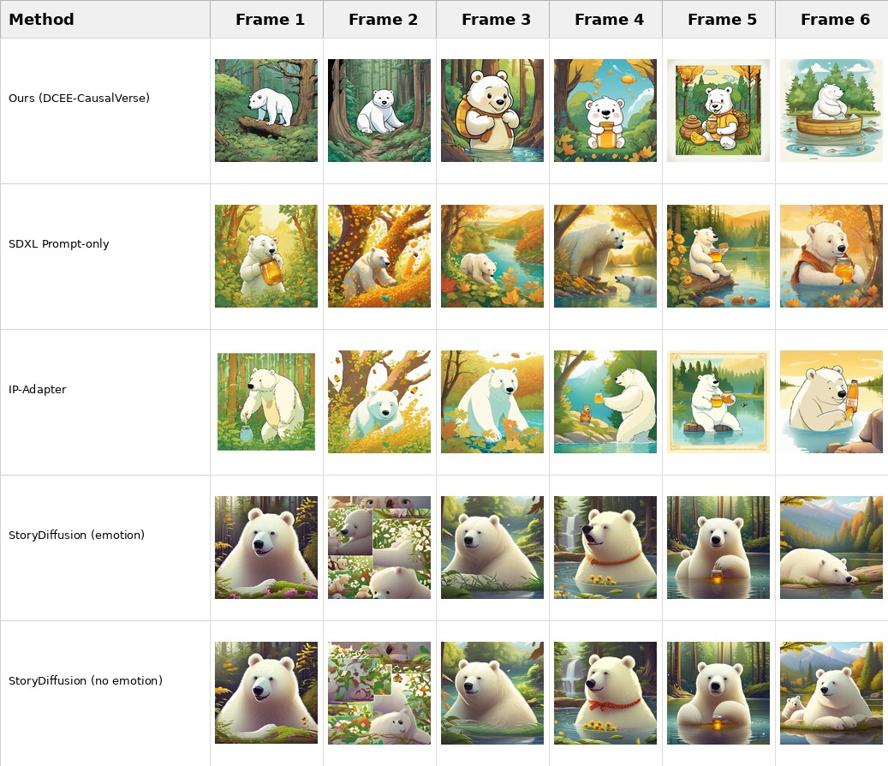
Figure 3. Qualitative comparison used for the automatic quantitative evaluation. All methods are conditioned on the same six-frame storyboard, while DCEE-CausalVerse additionally uses its event-grounded causal planning and memory/anchor controls.

Table 5. Automatic quantitative results averaged over the selected six frames.
Method | CLIP-T ↑ | CLIP-I ↑ | TIFA ↑
Ours (DCEE-CausalVerse) | 0.3352 | 0.6904 | 0.3667
SDXL Prompt-only | 0.3456 | 0.6274 | 0.6667
IP-Adapter | 0.3422 | 0.6699 | 0.6667
StoryDiffusion (emotion) | 0.3418 | 0.6699 | 0.5000
StoryDiffusion (no emotion) | 0.3479 | 0.6673 | 0.6333
The automatic results show that DCEE-CausalVerse obtains the highest CLIP-I score (0.6904), suggesting stronger average visual consistency across the generated story frames. However, the current implementation does not yet outperform the baselines on CLIP-T or TIFA. This indicates that the proposed causal planning and consistency modules improve cross-frame stability, while local object/action faithfulness and explicit visual evidence rendering remain important areas for refinement.
These findings support the motivation for event-evidence-aware reranking and retry generation: a coherent visual story requires not only a stable protagonist and world state, but also reliable depiction of the specific action and evidence object required by each story sentence.
4.6. Ablation Plan
Table 6. Ablation settings for analyzing the contribution of each major component.
Ablation setting | Removed or modified component | Diagnostic question
w/o DCEE-Tree Planning | Use a single Desire-Conflict route instead of multi-route exploration. | Does route exploration improve causal support for the target ending emotion?
w/o Entity-Event Canonicalization | Use raw LLM events and references without normalization. | Does converting abstract events into drawable entities/actions/evidence improve visual grounding?
w/o Causal Sink Memory | Replace event-emotion memory retrieval with recent or all history. | Does causal memory retrieval outperform generic temporal context?
w/o Anchor Bank | Remove character, evidence-object, and world anchors. | How much do persistent anchors contribute to identity, object, and world consistency?
w/o Evidence Branch | Merge evidence information into the event prompt instead of modeling it separately. | Is explicit evidence control necessary for emotion-cause legibility?
w/o Butterfly Controller | Replace decoder-encoder-decoder factorized control with direct storyboard-to-prompt conversion. | Does the Butterfly controller reduce prompt entanglement and improve controllability?
w/o Reranking and Retry | Select the first generated candidate without event-evidence-aware reranking or targeted retry. | How much does candidate selection and repair improve final frame faithfulness?
Table 6 isolates the major sources of performance in DCEE-CausalVerse. The ablations separate planning effects (DCEE-Tree and canonicalization), continuity effects (causal sink memory and anchor bank), control effects (Evidence branch and Butterfly controller), and selection effects (reranking and retry). This design supports component-level analysis without introducing unrelated architectural changes.
4.7. Human Evaluation
Human evaluation will compare methods using pairwise preference and Likert scores. Annotators will judge narrative coherence, character consistency, event visibility, evidence visibility, emotion delivery, ending controllability, and overall visual appeal. We will additionally ask whether the viewer can explain why the protagonist feels the final emotion based solely on the image sequence. This last question directly measures the central goal of event-evidence-grounded emotional storytelling.
5. Discussion
DCEE-CausalVerse is designed to make visual storytelling more causally explainable. Its main strength is that it does not rely on emotion words alone; it constructs events and visible evidence that justify why the protagonist arrives at a target ending emotion. The automatic results support this motivation by showing stronger cross-frame consistency, while also revealing that local caption faithfulness and evidence visibility remain challenging. This trade-off is important: a visually coherent story can still fail if the required object or action is missing from a frame. Therefore, the Event and Evidence branches should be treated as first-class control factors rather than optional prompt details. The current implementation remains partly LLM-driven and uses lightweight control-token injection rather than a fully trained diffusion backbone, which makes it modular but also leaves room for stronger object-level grounding, adaptive branch weighting, and larger-scale evaluation across more premises and target emotions.
6. Conclusion
We presented DCEE-CausalVerse, an event-grounded framework for ending-controllable visual storytelling. The method decomposes a target ending emotion into Desire, Conflict, Event Chain, and Ending Emotion, explores multiple routes through DCEE-Tree Planning, canonicalizes events into drawable evidence, maintains causal sink memory and anchors, and uses the decoder-encoder-decoder DCEE Butterfly Visual Controller to transform symbolic narrative causality into factorized diffusion controls. By separating Character, World, Emotion, Event, and Evidence branches and reranking candidates with event-evidence-aware metrics, the proposed framework aims to generate visual stories that show not only what the protagonist feels, but also why the emotion emerges. The automatic results indicate improved cross-frame consistency and clarify the remaining challenge of local event and evidence faithfulness, suggesting a path toward more interpretable, controllable, and causally grounded story visualization systems.
References
[1] S. Dong, I. Shaheen, M. Shen, R. Mallick, and S. A. Bargal. ViSTA: Visual Storytelling using Multi-modal Adapters for Text-to-Image Diffusion Models. WACV, 2026.
[2] X. Pan, P. Qin, Y. Li, H. Xue, and W. Chen. Synthesizing Coherent Story with Auto-Regressive Latent Diffusion Models. WACV, 2024.
[3] T. Rahman, H.-Y. Lee, J. Ren, S. Tulyakov, S. Mahajan, and L. Sigal. Make-A-Story: Visual Memory Conditioned Consistent Story Generation. CVPR, 2023.
[4] Z. Feng et al. Improved Visual Story Generation with Adaptive Context Modeling. ACL Findings, 2023.
[5] C. Liu et al. Intelligent Grimm: Open-ended Visual Storytelling via Latent Diffusion Models. CVPR, 2024.
[6] T. Song et al. Causal-Story: Local Causal Attention Utilizing Parameter-Efficient Tuning for Visual Story Synthesis. ICASSP, 2024.
[7] X. Shen and M. Elhoseiny. StoryGPT-V: Large Language Models as Consistent Story Visualizers. CVPR, 2025.
[8] Y. Zhou et al. StoryDiffusion: Consistent Self-Attention for Long-Range Image and Video Generation. NeurIPS, 2024.
[9] Y. Tewel et al. ConsiStory: Training-Free Consistent Text-to-Image Generation. ACM TOG, 2024.
[10] H. He et al. DreamStory: Open-Domain Story Visualization by LLM-Guided Multi-Subject Consistent Diffusion. TPAMI, 2025.
[11] S. Yang et al. SEED-Story: Multimodal Long Story Generation with Large Language Models. arXiv, 2024.
[12] Y. Hu et al. TIFA: Accurate and Interpretable Text-to-Image Faithfulness Evaluation with Question Answering. ICCV, 2023.
[13] D. Podell et al. SDXL: Improving Latent Diffusion Models for High-Resolution Image Synthesis. ICLR, 2024.
[14] StoryGAN, CVPR 2019
[15] StoryDALL-E, ECCV 2022
[16] Plan-and-Write, AAAI 2019
[17] PlotMachines, EMNLP 2020
[18] Controllable Neural Story Plot Generation via Reward Shaping, IJCAI 2019
[19] One-Prompt-One-Story, ICLR, 2025
[20] Hierarchical Neural Story Generation, ACL, 2018

